{Discipline} Teaching Laboratory  School of Medical Sciences  Student Risk Assessment |  | [INSERT NAME OF PRACTICAL CLASS HERE]  Insert document control details here

Hazards | Risks Controls
Insert hazards here e.g.  Ergonomics  Electrical | Insert associated risks e.g.  - Musculoskeletal pain  - Eyestrain  - Electrical shock/fire | Insert control measures in the class e.g.  - Fully adjustable chair available  - Computer screen and equipment adjustable  - Microscope adjustable  - All portable electrical equipment tested and tagged.  - Check electrical equipment in good condition before use.  - Students advised on the correct set-up of workstation  - Sessions at the microscope limited to less than an hour

Workstation set-up
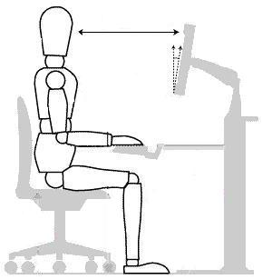
Adjust seat back for lumbar support
Monitor positioned arm-distance away
Top of monitor at eye-height
Monitor tilt
Elbow at 90º angle

Microscope set-up
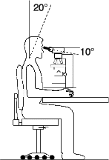
Adjust seat back for lumbar support
Eyes level with top of eye-piece
Back and neck straight
Adjust height of chair so that eyes are at the level of the eye pieces, shoulders are not hunched, back is straight and neck is not excessively flexed (no more than 10-15 degrees below the horizontal).

Personal Protective Equipment
Not necessary in these practicals.

Emergency Procedures
Insert details in the event of an emergency e.g. “In the event of an alarm, follow the instructions of the demonstrator. The initial sound is advising you to prepare for evacuation and during this time start packing up your things. Switch off the power to the microscope. Return the slide to its case, secure the case and take the case with you. The second sound gives instruction to leave.”

Clean up and waste disposal
Insert details for clean-up and waste, or if there is none state “No apparatus used in these practicals.”

Declaration
I have read and understand the safety requirements for this practical class and I will observe these requirements.

Signature:……………………………………………………………Date:……………………………

